# FACTSHEET

The Biotech Center of Excellence

With a particular focus on treatments for rare diseases, the Biotech Center of Excellence in Parma strives to lead innovation in biopharmaceuticals, specializing in the development and production of monoclonal antibodies, enzymes, and other complex proteins. It is Chiesi Group’s most advanced facility, designed to cover the entire biologics production process, from cell culture to finished product. This comprehensive approach encompasses the production of drug substances and drug products, including the final packaging and quality testing stages, ensuring a complete supply chain under one roof. By consolidating all production phases, the Center achieves cost efficiencies, improves quality control, and enhances supply chain robustness.



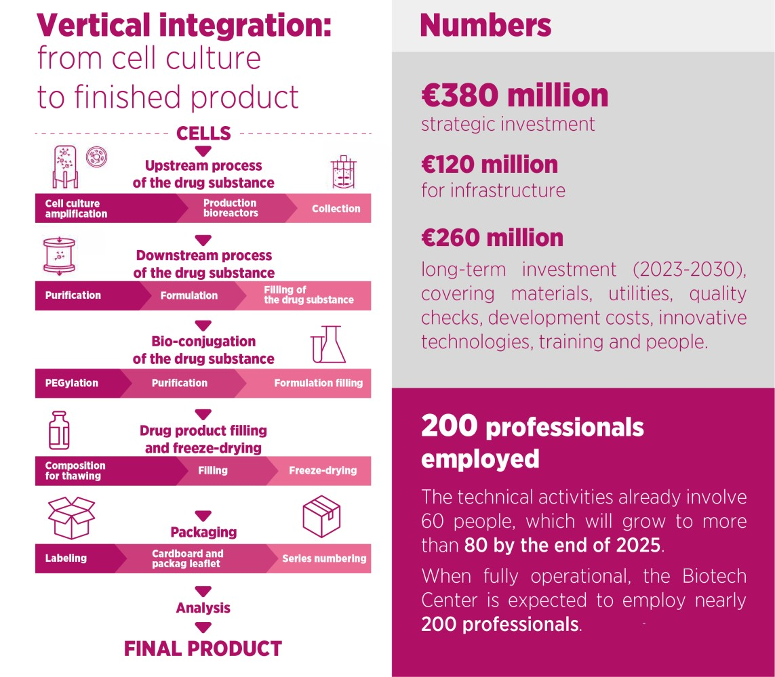

R&D and manufacturing

“*The Biotech Center of Excellence is equipped with state-of-the-art technology to handle the complexities of biologic drug production. This includes the flexibility to adopt new processes, crucial for producing biologics, which are inherently more complex than traditional chemical-based medications.* *For Chiesi, the investment in the Biotech Center is not only aimed at ensuring production capacity autonomy to safeguard the future of our patients, but it is also driven by the desire to create internal know-how, with a connected research center, one of the few in Europe.*” Antonio Magnelli, Executive Vice President, Global Manufacturing Division.

# FACTSHEET

“*Chiesi initially accessed the biological sector mostly through the acquisition of externally developed products, at various stages of maturity. This successful approach provided a valuable foundation for expanding our expertise, increasing investments, and building the necessary know-how in the field. Once we had achieved a critical mass of competencies and products, we made the strategic decision to invest directly in our own production capabilities. This approach is designed to allow us to grow our pipeline by leveraging a unique and focused model of integration across research, development, and manufacturing.”*

Diego Ardigò, Executive Vice President, Global Research & Development

The close collaboration between R&D and manufacturing plays a crucial role in the acceleration of technology transfer, a delicate process in the biotech field involving transportation, handling, and maintenance. By integrating R&D insights directly into manufacturing, the Biotech Center ensures that new scientific findings are smoothly transitioned into production. This approach avoids last-minute changes and ensures that manufacturing processes remain closely aligned with the latest scientific advancements, streamlining drug development, and optimizing quality.

Key manufacturing capabilities

* Flexible production volumes - the facility supports both clinical and commercial production, offering flexibility for both rare and ultra-rare disease treatments as well as larger-scale production. The ability to produce small quantities of medicines is crucial for rare disease treatments, which often require customized, smaller batch sizes. This gives the center a competitive edge in delivering high-quality, specialized therapies to patients.



* Drug Substance Production Scale: the Center is designed to handle working volumes ranging from 250L to 2000L for upstream processes.
* Drug Product Capacity: the facility produces pharmaceutical forms in vial sizes ranging from 2R (2ml vials) to 100R (100ml vials).

Key R&D capabilities

* Global Expertise Integration – Chiesi's R&D network spans internationally, with Sweden focusing on drug substance expertise and Parma leading drug product development, enabling efficient management of complex biotech projects.
* Diverse Biotech Portfolio – the R&D efforts focus on AIR (respiratory conditions), CARE (specialized treatments), and RARE (rare diseases), addressing a wide range of medical needs through innovative biotech solutions.
* Collaboration and Talent Magnet – Chiesi’s R&D division partners with academic institutions and attracts global talent, offering opportunities to work on cutting-edge technologies, particularly in rare diseases and specialized therapies, with both scientific and social impact.